Table1 Basic properties of asphalt binders.
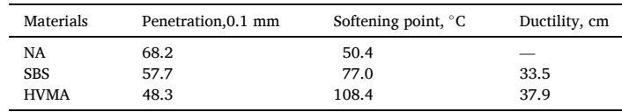

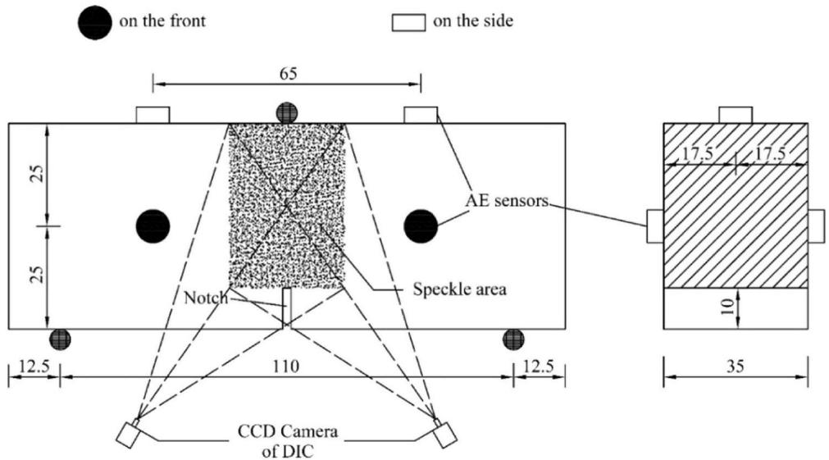
Fig. 2. Schematic diagram of AE sensors position and speckle area (unit: mm).
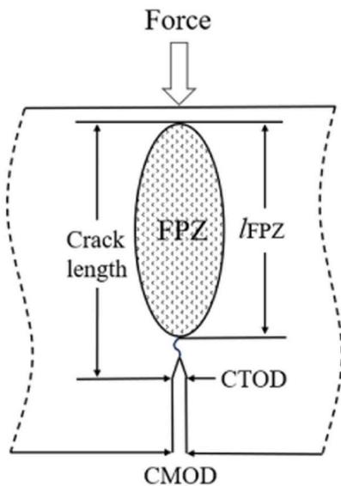
Fig. 3. Schematic diagram of CTOD.
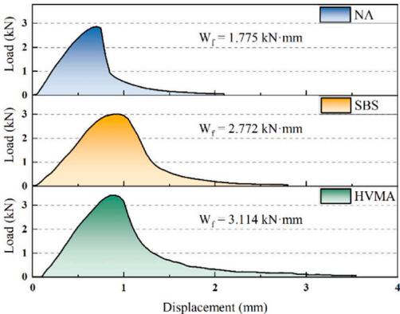
Fig. 4. Load-displacement curve and work of fracture.
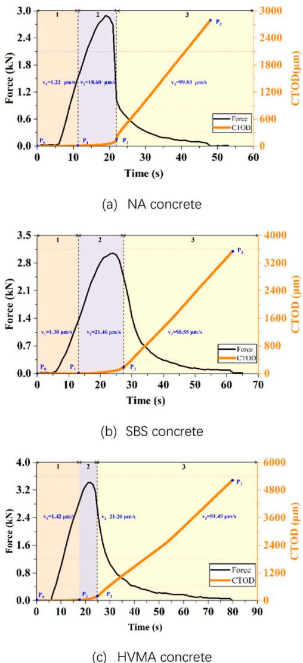
Fig. 5. Evolution of CTOD and loading curve throughout loading process.
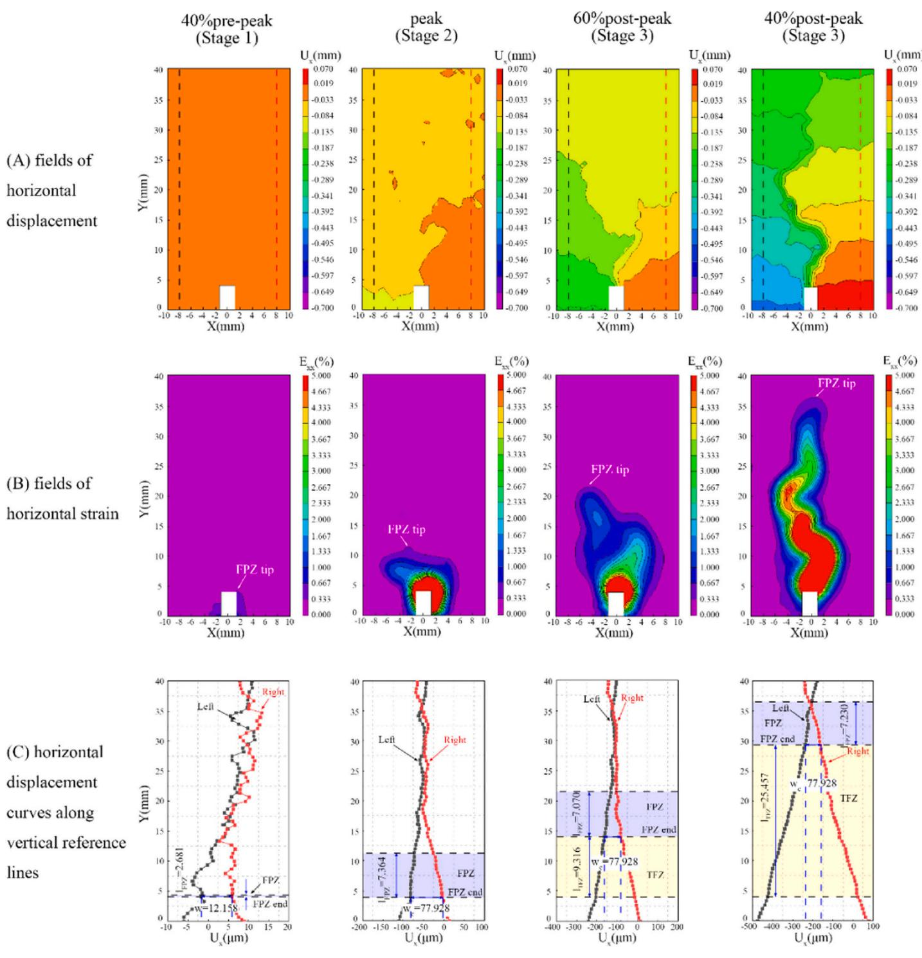
Fig. 6. Analysis of the FPZ and TFZ in concrete sample with NA concrete under different fracture stages.
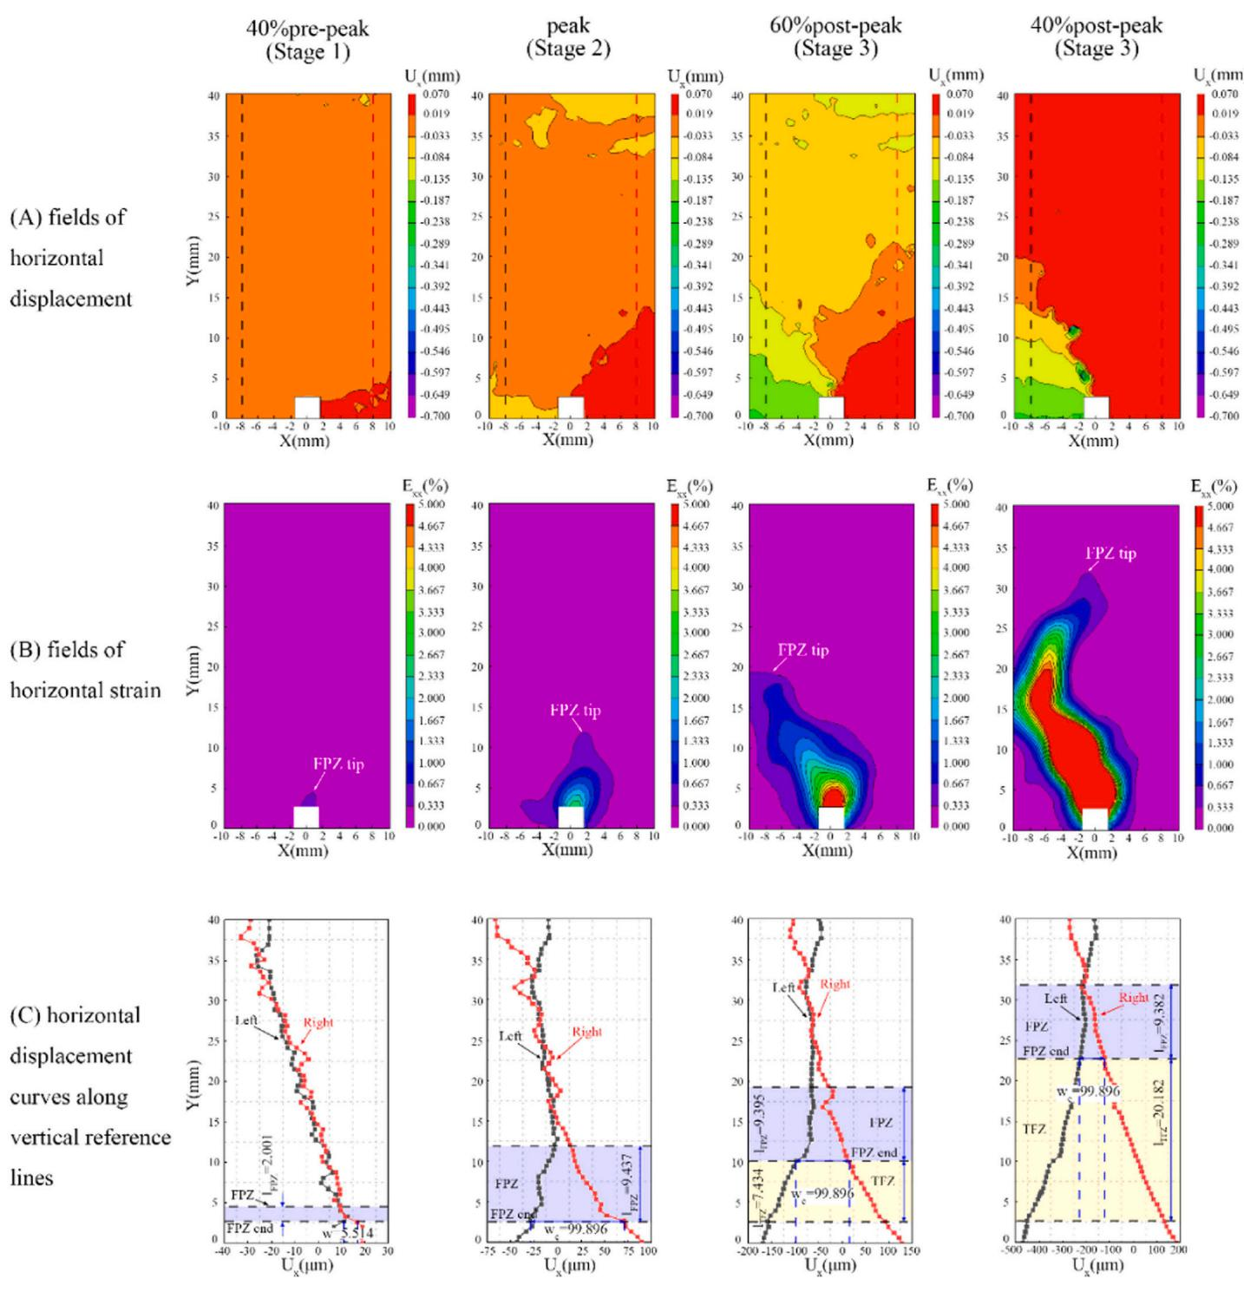
Fig. 7. Analysis of the FPZ and TFZ in concrete sample with SBS concrete under different fracture stages.
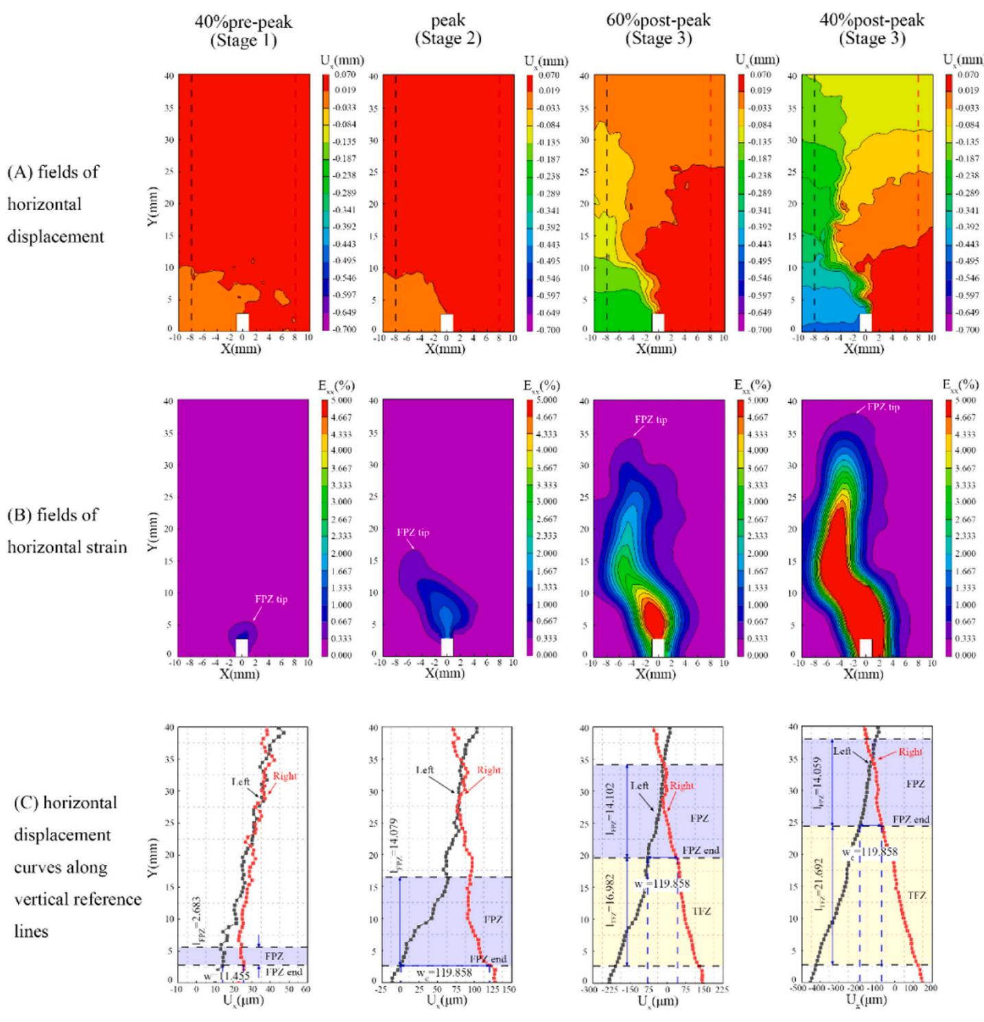
Fig. 8. Analysis of the FPZ and TFZ in concrete sample with HVMA concrete under different fracture stages.
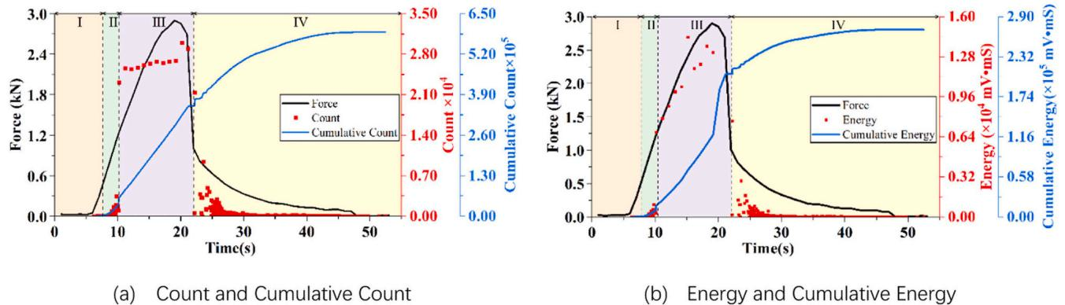
Fig. 9. Temporal evolutions of the load and AE characteristics of NA concrete.
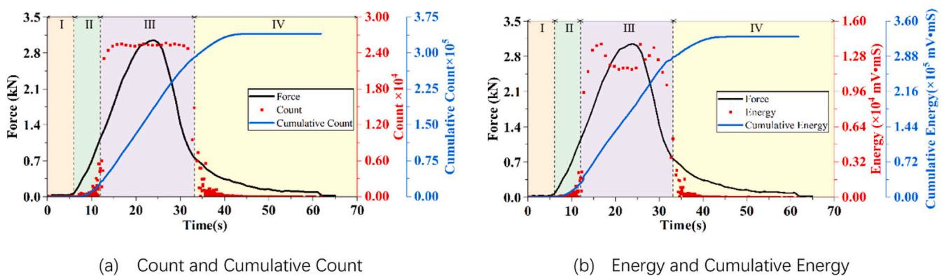
Fig. 10. Temporal evolutions of the load and AE characteristics of SBS concrete.
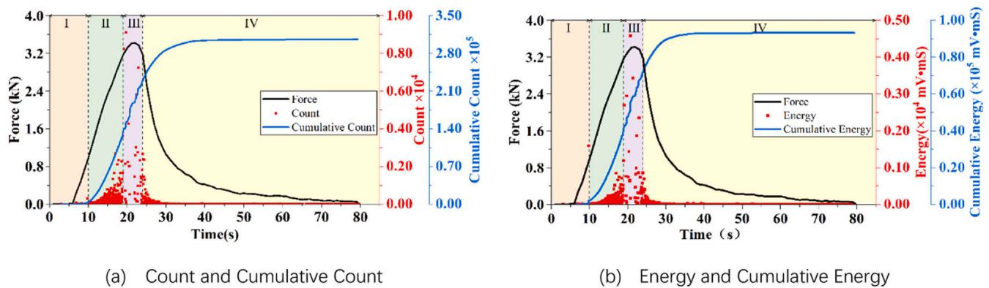
Fig. 11. Temporal evolutions of the load and AE characteristics of HVMA concrete.
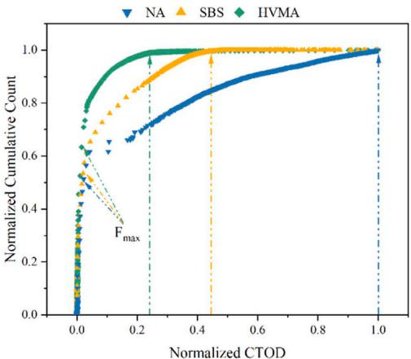
Fig. 12. Crack extension in relation to the cumulative count.
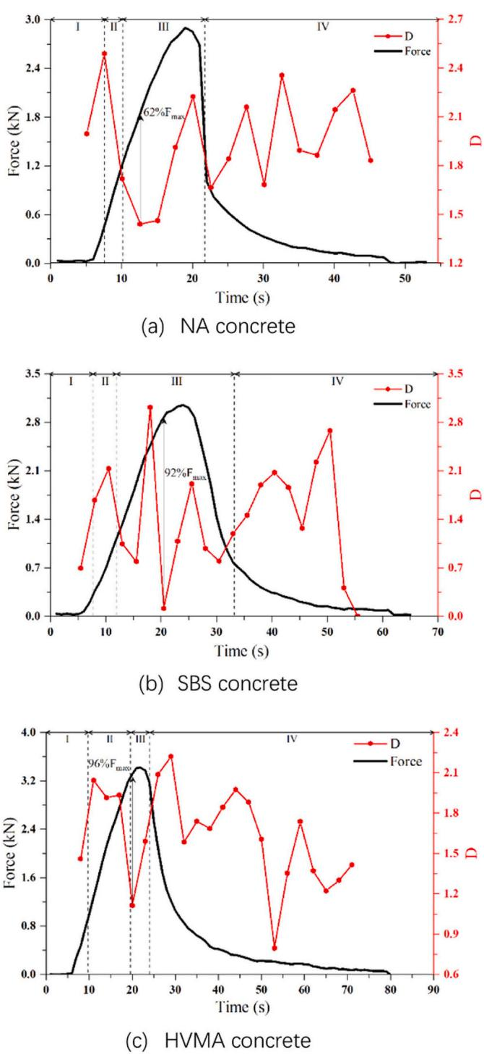
Fig. 13. Correlation dimension D versus time.
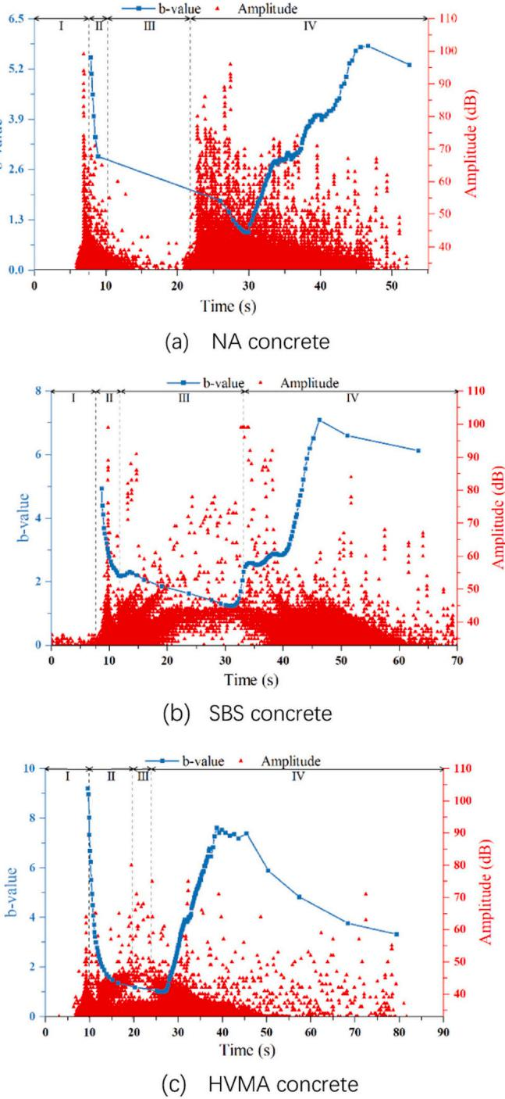
Fig. 14. AE b-value versus time.

